*The last four digits will not appear on your billing statement because we read to the 100^{th.}
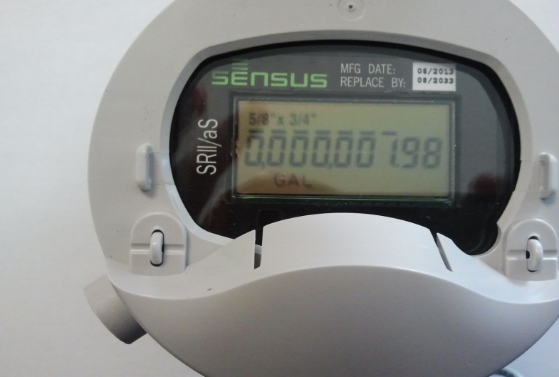
Sensus Meter- If you have a possible leak then the numbers after the decimal will be moving. Please allow 5 seconds for movement. If numbers do not appear, you may have to open & close the gray case to wake the meter up.
*Be sure that no one is using water inside the house when checking meter.

Movement after decimal Indicates leak

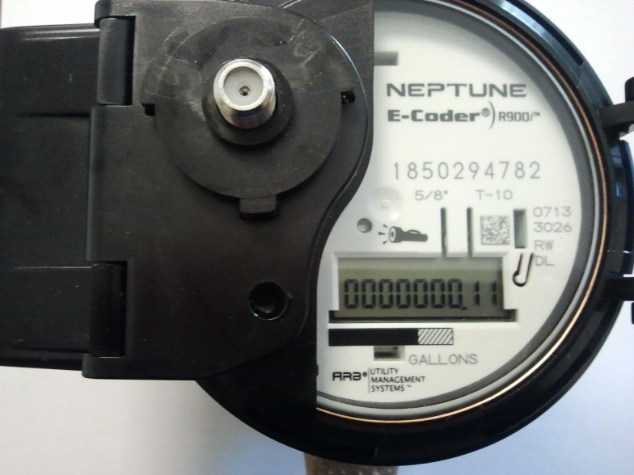
Neptune Meter- If you have a possible leak two things will occur 1.) An image of a faucet will appear on the display. 2.) The numbers after the decimal will be moving. Please allow 5 seconds for movement. If numbers do not appear, shine a bright flash light on the face of the meter and digits will appear.
*Be sure that no one is using water inside the house when checking meter.

Movement after decimal Indicates leak

Unlike the meters above the reading for our master meters as seen below would be 5911.
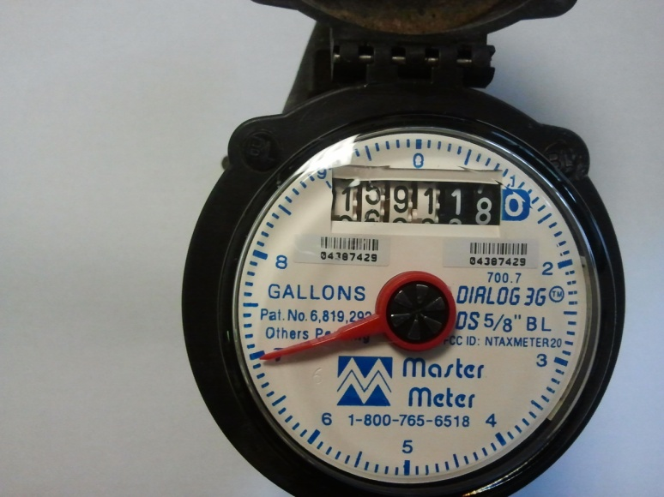
Wheel will be turning
Master Meter- If you have a leak, the wheel in the middle of the meter will be turning.
*Be sure that no one is using any water inside the house when checking meter.

